EdGems Whitelist 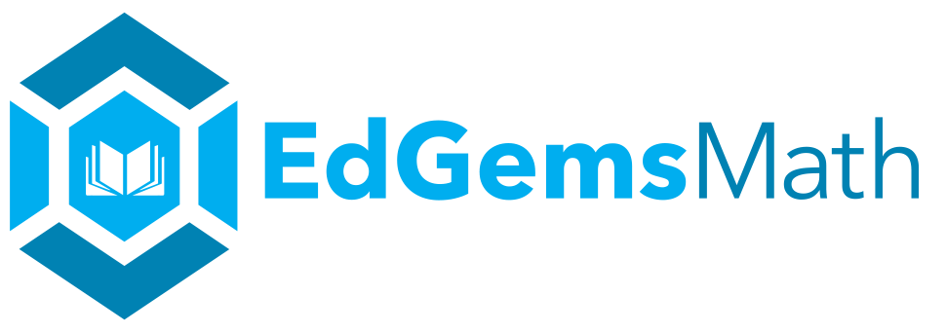

www.edgems.com

https://d28n74cemeobyg.cloudfront.net/

https://pro.activetextbook.com/

https://onedrive.live.com/

OER Resources

www.actuarialfoundation.org

www.annenberg.org

http://www.asset.asu.edu/

www.bbc.co.uk

https://www.sproutvideo.com/

http://ccsstoolbox.agilemind.com/

www.cosmeo.com

http://www.crickweb.co.uk/

www.desmos.com

www.doubledivision.org

http://figurethis.nctm.org/

www.fractionfrog.com

www.geogebra.org

www.illuminations.nctm.org

www.illustrativemathematics.com

www.ixl.com

www.khanacademy.com

www.mathantics.com

www.mathmess.com

www.mathsnacks.com

www.pbslearningmedia.org

http://pbs.panda-prod.cdn.s3.amazonaws.com

https://phet.colorado.edu

www.threeacts.mrmyer.com

www.visualfractions.com

EdGems Teacher Gems Video Links

videos.sproutvideo.com/embed/a49bdfbb1017e3ca2c/de01deeaba23629e

videos.sproutvideo.com/embed/1c9bdfb41d19e7cc94/125890b88694d4f7

videos.sproutvideo.com/embed/a49bdfbb1018edcb2c/48d0dbc14eae413f

videos.sproutvideo.com/embed/189bdfbb1016e8c390/463bb105f4627822

videos.sproutvideo.com/embed/189bdfbb1017e2c890/1e0186d7abbc4f22

videos.sproutvideo.com/embed/4c9bdfbb1017eec5c4/870da940ac55dce5

videos.sproutvideo.com/embed/1c9bdfbb1016e9cf94/6e9ef6d96931e9cd

videos.sproutvideo.com/embed/7c9bdfbb1017ebc4f4/4fc2acbef7e92044

videos.sproutvideo.com/embed/189bdfbb1016eac190/10df0c4d8d10d279

videos.sproutvideo.com/embed/a09bdfbb161ae4c328/572759f05fbc8b4f

videos.sproutvideo.com/embed/7c9bdfbb1017e9c6f4/52ec68afa85cbbf8

